## Exercise 1.2.5: The <title> Tag

In this exercise, you’ll practice using the <title> tag.

The given HTML code displays Karel’s webpage, but there is no title for the page!

**Your Job**

Set the title of the web page to be “All About Karel”

If you click on the “See HTML in new window” button, you should be able to see the title of the webpage in the browser tab, like this:

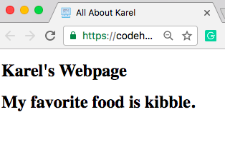

Your browser may try to block the new window from popping up, simply click “Allow Pop Ups” and you’ll be able to see your webpage!

**HINT**

* You’ll need to use the <title> tag.
* You’ll need to decide whether the <title> tag should go in the <head> or the <body>